ACCOMPLISHMENT REPORT
IT 205 & 205L – Object-Oriented Programming
Month: December – Year: 2025
School Year: 2025 – 2026 1st Semester

DATE | ACCOMPLISHMENT | REMARKS  (Progress and deviations from the plan) *
December 1 – 5, 2025 | Lecture Accomplishments:  - Completed the remaining coverage of Module 4: Inheritance and Polymorphism in OOP.  - Discussed inheritance fundamentals.  - Demonstrated creating base and derived classes using extends and super, including constructor chaining.  - Covered method overriding and polymorphism through common interfaces/behaviors.  - Administered a short quiz and conducted guided recitation to check mastery of Module 4 concepts. | Accomplished  (Module 4 learning outcomes on inheritance, polymorphism, and hierarchy analysis were delivered; additional time was used to address misconceptions on prototype vs class syntax, but coverage was completed.)
December 8 – 12, 2025 | Lecture & Laboratory Accomplishments: [EXAMINATION WEEK]  - Prepared and administered the Final Examination covering Modules 3–4 (Inheritance and Polymorphism).  - Implemented standard testing controls: clear instructions, time allocation, and academic integrity reminders.  - Checked and recorded scores; performed item review on commonly missed questions for post-exam feedback. | Accomplished  (Final assessment was administered and checked; a small number of students required make-up arrangements due to validated absences, handled per campus policy.)
December 15 – 19, 2025 | Lecture Accomplishments:  - Completed checking and consolidation of all lecture requirements (quizzes, activities, performance tasks, and final exam).  - Computed final lecture grades following the syllabus grading components and verified entries in the class record.  - Conducted consultation/feedback sessions and addressed student clarifications on scores and grading basis.  Laboratory Accomplishments:  - Administered final practical evaluation and checked laboratory outputs (inheritance-based mini-scenario/code submissions).  - Validated code quality: correct use of constructors, inheritance/overriding, documentation, and basic debugging practices.  - Archived final laboratory outputs and prepared evidence for completion of Semester 1 requirements. | Accomplished  (Semester [Final Term] 1 was finalized: grades computed, records validated, and outputs archived).
*Provide relevant documentation such as pictures, summary reports, etc.

Prepared by: Approved:

JUNNIE RYH M. SUMACOT SHERWIN G. CADAY, PhD.
Instructor Program Chair
PROOF/EVIDENCE OF REPORTED ACCOMPLISHMENTS
IT 205 & 205L – Object-Oriented Programming
Month: December – Year: 2025
School Year: 2025 – 2026 1st Semester

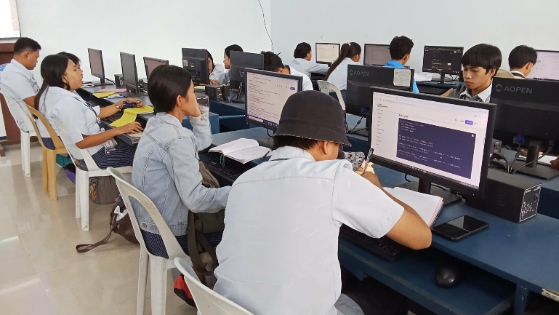
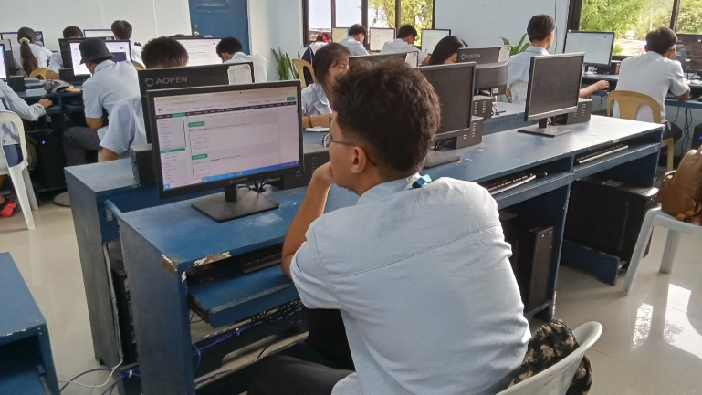

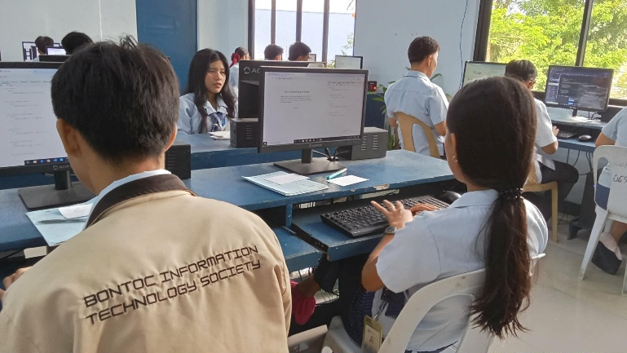
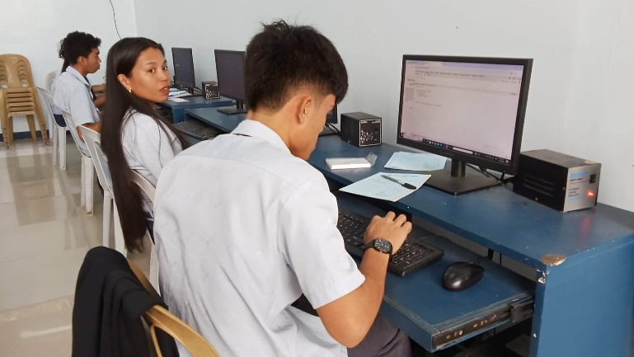

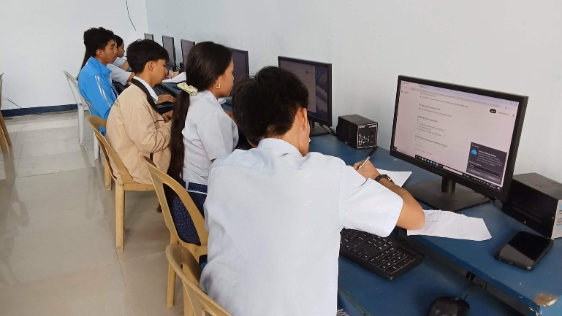
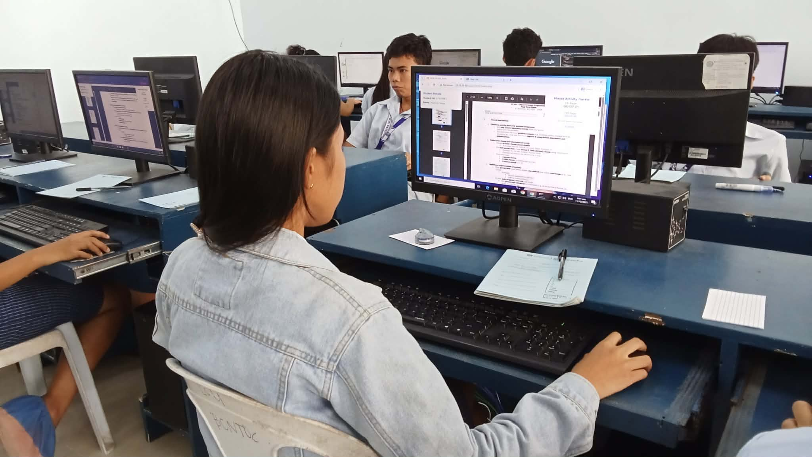

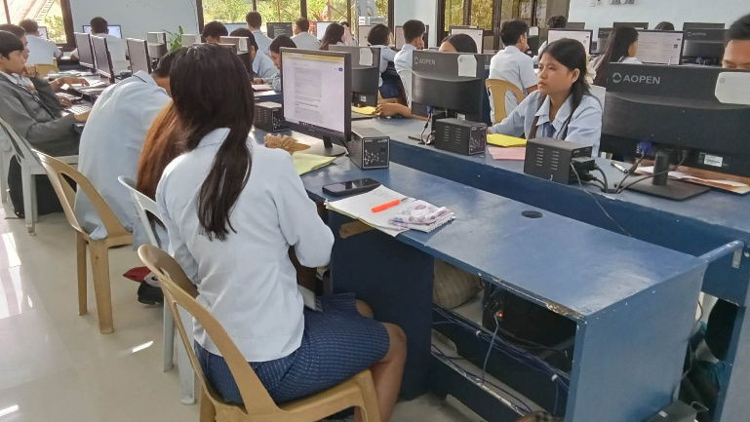
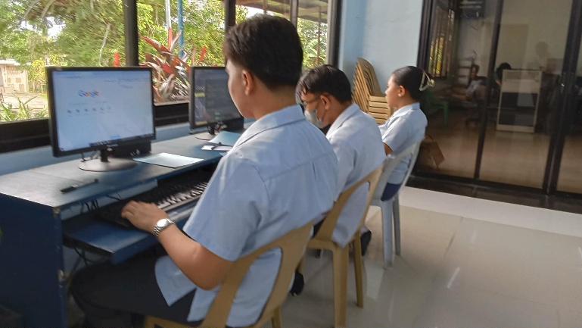

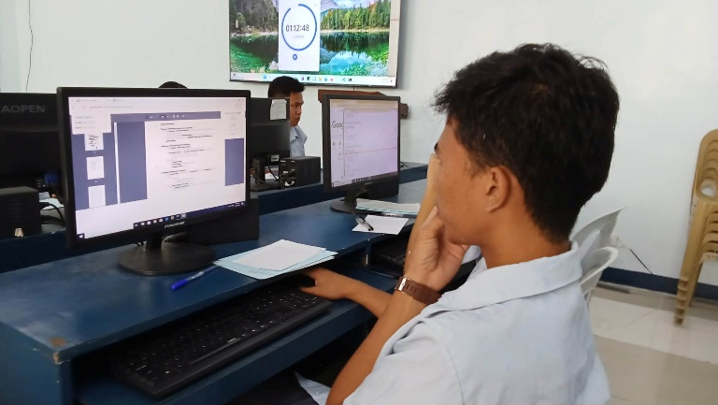
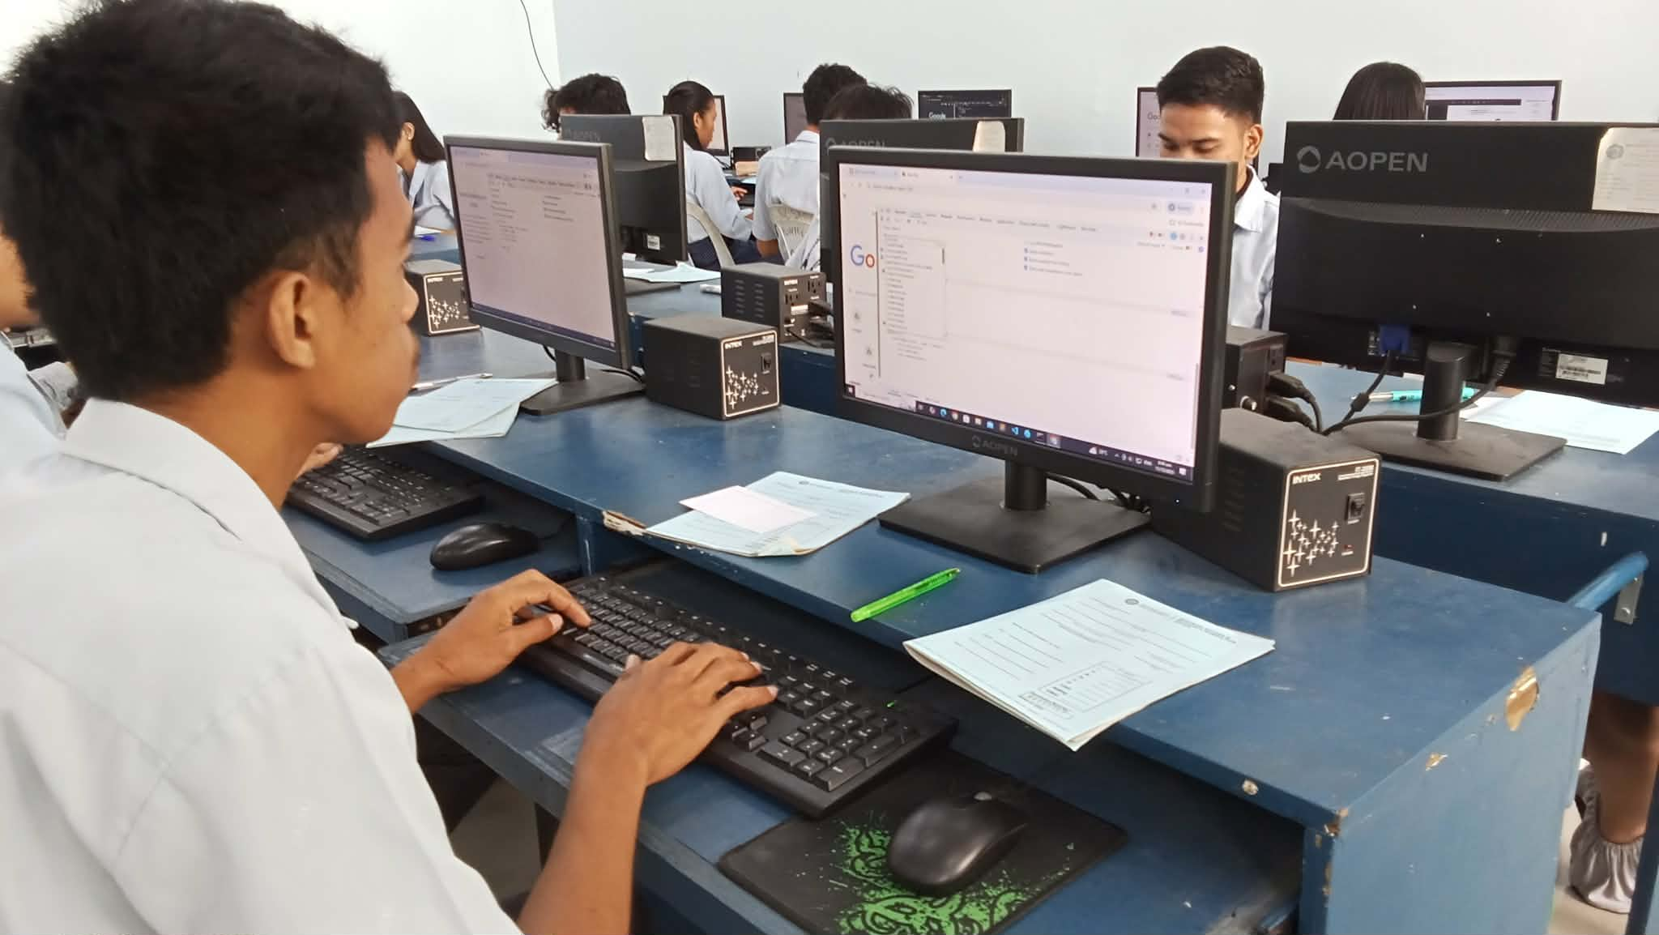
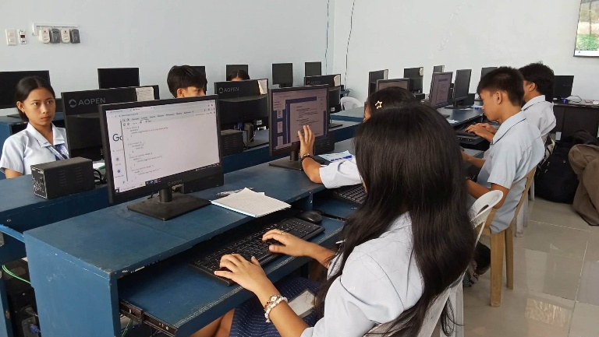
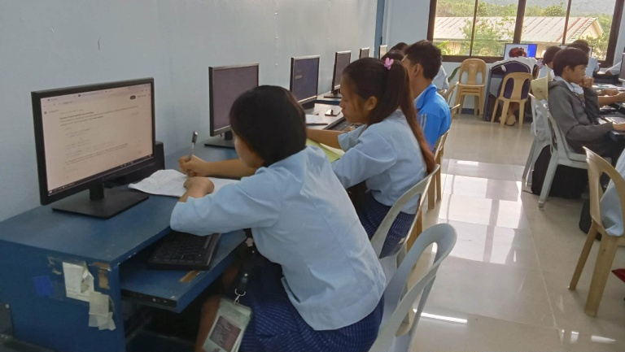

Prepared by: Approved:

JUNNIE RYH M. SUMACOT SHERWIN G. CADAY, PhD.
Instructor Program Chair

